HOW TO READ SURVEYS, DESCRIPTIONS, AND PLATS
NBI “TITLE LAW FROM START TO FINISH”

Real estate lawyers must be well versed in many aspects of real estate law including the ability to read and understand surveys. Surveys are important in the development of real estate locating improvements, for construction of real estate, to establish boundaries, to provide visual representations of property being purchased or sold. In addition, owners of real estate use surveys to review encroachments and building site problems. Litigants use them in adverse possession claims. Parties needing to create easements, roads and other interests in land also require the use of surveys. In developing real estate, surveys are essential for subdividing large tracts of property into smaller tracts and lots.
- Survey Basics
- What is a Survey?
A survey is a visual depiction of measurements. In addition, ‘to survey’ means the surveying activity including taking field measurements, preparing evidence, taking notes, reviewing data and forming opinions about the data.
- Who Prepares the Surveys?
Surveyors are professionals licensed from state to state with specialized training. Licensing of surveyors is supervised by the Georgia Board of Professional Engineers and Land Surveyors, 237 Coliseum Drive, Macon, GA 31217-3858. Only a professional land surveyor may locate land boundaries, perform work involving land monuments, and set boundary corners, prepare drawings depicting the shape, location and dimensions or area of land, and prepare plats and maps showing improvement and construction upon land, among other things.
- What is the Purpose of a Survey?
Any time a property is being purchased, when improvements are being built, or in connection with any financing transaction involving real estate, a current survey should be obtained. Surveys are necessary in order to create plats, to divide lots, to create subdivisions and condominiums, and to create boundary adjustments. Only with a survey can one determine that an improvement is where it is supposed to be and that a legal description depicts what is expected. It is important to have a survey also in connection with the issuance of title insurance and obtaining the sort of title coverage that one would wish to have for as much coverage as possible from liability issues. Under the standard ALTA (American Land Title Association) title insurance policy, normally only the exceptions for the encroachments or questions of location and for unrecorded easements (the standard survey exceptions) are removed if one provides a “spot survey” or if one provides a non-current survey. However, this does little for the client in showing the location of improvements and encroachments over boundary lines, the location of utilities, the location of rights of way, the location of boundaries of adjoining owners, the configuration of parking, access to the property and other unrecorded matters affecting the property.
Given the potential for liability and risk to a purchaser of real estate, whether residential or commercial, it is highly recommended that a current survey be ordered prior to any transaction.

- Ordering the Survey
As soon as the real estate contract is entered into, if not prior to that time, the survey should be ordered. Often, a seller of property, in marketing the property (particularly commercial properties) will have a survey available that may have been performed when the seller acquired the property. If so, it is sometimes helpful to have a copy of that survey sent along with the order for either an updated survey or a new survey from a different surveyor. It is not unusual for a survey to take up to three or four weeks to perform, depending on the nature of the property. The survey should be ordered as early in the process as possible. Much of the due diligence that is required to be performed once the sale contract has been executed hinges upon having the survey in place and having a title insurance commitment available.
Typically a written order is placed with the surveyor and includes the type of survey and the items to be included, the amount of time required to provide the survey, the fee for the surveyor and the cost or additional charges for indicating on the survey any other matters that are not standard. The number of copies and to whom they are to be provided should be included. In addition, it is helpful to inquire at the time that the order is placed, if not sooner whether or not the surveyor carries professional liability insurance and the amount.
In addition, it is helpful if the surveyor is provided with an existing survey, the record legal description and copy of the title commitment on the property, together with all exception documents shown on Schedule B of the title commitment, and any other important information that the client feels is necessary or helpful for the surveyor in performing the survey. Formerly, it was necessary to be familiar with classifications for surveys including “urban, suburban, and rural, among others.” In 1999, the standards were revised and the classifications are no longer important.
- Types of Surveys
Several types of surveys are available, including boundary, land title, improvement location, and as built surveys. Topographic surveys are often used when construction is contemplated on a property.
- ALTA Survey
The most common type of survey that is used in commercial transactions these days is the ALTA survey which is a survey prepared according to the “minimum standard detailed requirements” adopted by the American Land Title Association and the American Congress on Surveying and Mapping, and the National Society of Professional Surveyors. An ALTA survey typically shows where the boundaries are located, easements and locatable exceptions appearing on a title commitment for the property, major improvements located on the property, and utilities and access serving the property. In addition to the usual types of items shown on these surveys, there is an optional items table that includes such additional items that can be requested such as showing the location of highways and major street intersections, flood zone designations, measured height of buildings, and parking areas and numbered spaces, in addition to other items.
- Boundary Survey
These surveys are often used in residential transactions and when putting in a fence or making other improvements to property. It is not as comprehensive as an ALTA Survey, but it is far better than a “spot survey”. Research is often done of surrounding tracts and requires field work and location of monuments. Improvements, roadways and easements are located.
Surveyor’s Real Property Report (SRPR) (i.e., “spot survey”)
Not as reliable or thorough as a Boundary Survey, this type of survey is often ordered in the standard residential real estate purchase or refinance. It is a location of the improvements and a cursory check for encroachments. These are not to be used for commercial properties.
- Certification
Another critical aspect in the ordering process is to order the form of certification that is important for your particular client and transaction. The ALTA/ACSM standards have a short certification that states that the survey has been performed in accordance with the standards and includes specific optional items. The standard certification is what most clients seem to benefit from. However, certain institutional lenders and others may require far lengthier certifications and these certifications need to be submitted to the surveyor to determine if they will provide them or not ahead of time.
In addition, in connection with the certification, it is very important that the proper parties be included in the certification. Typically the certification is made to the owner, the buyer, the lender, and the title company.
- Reviewing the Survey
Once the survey is received, it is critical in any transaction for the attorney to review the survey with an eye towards inclusiveness of items shown on the title commitment, and observing issues that were unknown prior to the survey being performed. It is helpful to have a checklist available that is either customized for a particular type of transaction or a general one that can be used with any type of property or project, in order to make sure that all the bases are covered.
Some of the more important aspects of survey review include the following:
1. The survey and the title commitment should conform; the legal description should match what is shown on the title commitment and the various encumbrances, appurtenant easements, and other matters appearing on the title commitment should all be properly shown on the survey;
2. The surveys should be reviewed for additional matters that do not appear on the title insurance commitment, such as additional easements not appearing on the title binder, insuring that there is access as expected by the purchaser involved, that all utilities are present on the property, that there is sufficient parking, that there are or are not appurtenant easements to the property needed for utilities, that no structures encroach over the property line or into any easements;
3. That the survey shows the correct number of improvements with the correct addresses. In looking at a survey, it is important to check the survey information including the scale, the north arrow, the legend, if any, the date the field work was completed, updated and the map drawn, the certifications and the surveyors seal and signature.
H. Legal Descriptions and the Survey
“Metes and Bounds” Legal Descriptions. Starting with the legal description, it is important to follow the “metes and bounds description” (meaning measurements and boundaries). The review should start at the point of beginning of the survey which is typically where the first bearing proceeds from after the point of beginning. The first bearing relates to a previously established line, perhaps a section line or a subdivision line, or a road). The description then follows the property boundaries along the courses and distances shown on the survey back to the point of beginning.
It is important that the description closes. The ALTA/ACSM certification assumes that there is closure in legal descriptions. (There are various forms of software available that will review a legal description to make sure that it closes.) Oftentimes legal descriptions are created by non-surveyors including attorneys, title officers and real estate agents who know enough about real estate and/or have enough information to be able to properly create a legal description. One who creates a legal description of the “south one-half of lot 1” usually will not have too much trouble if they know what “lot 1” looks like. However, it is important if not critical to have a surveyor prepare a correct metes and bounds legal description.
Typically, a surveyor in the field will attempt to locate previously set monuments establishing the boundaries of a piece of property. Some older legal descriptions use boundaries of old fences, “the old oak tree”, or rivers. Also, previously, some of the tools used were not exactly accurate. These included metal chains that stretched and contracted with the weather. (Older legal descriptions sometimes refer to “chains” and “links” as measurements.)
J. Rectangular System/ Government System
Another type of legal description is based on the rectangular system or government system which was adopted by the Continental Congress in 1785. Legal descriptions of this type are fairly common, especially in parts of the Southeastern United States. They are based on portions of the sections in a certain township and range with reference to a particular meridian. There are 36 sections in one square mile for a total of 640 acres. Each section is typically divided into further quarters and quarter quarter sections.
If you are reading or reviewing a legal description that is based on the rectangular system (the township and range type) it is oftentimes easier to work backwards through the legal description to locate where you are. See Section III below for more information on reading this type of survey.
K. Subdivision Legal Description
A third type of legal description is based on the subdivision of land. Most real estate attorneys have been exposed to a legal description such as “Lot 5 in block 4 of Pleasant Hills Plat 2, a subdivision in Fulton County, Georgia, according to the plat recorded in Plat Book 10 page 5 of the Fulton County records.” The subdivision name refers to a recorded subdivision plat that is recorded in the county recorders office. Typically all of the easements roadways and utility easements are shown on the subdivision plats in connection with the approval process that typically occurs in the county where the subdivision is established.
The legal description on the survey should be the same as the legal description in the title commitment. The legal description and the title commitment generally come from the last vesting deed on the property. If there are differences between those legal descriptions, it is critical to determine those reasons for such differences because the seller of a tract of land that is described in a manner different than the deed where he purchased the property can create significant problems for the seller.
Sometimes there are differences in the deed that is used by the surveyor to create the measurements on the survey. Sometimes the measured call is different than the deed call. There are any number of reasons why there would be discrepancies in the legal descriptions including that the surveyor may have either made a typographical error, or that he started the description in a different place than on the title commitment. Regardless, it is important for the attorney to determine which is correct and have the surveyor reexamine and explain any discrepancies.
In addition to checking that the legal description on the face of the survey is the same legal description that appears on the commitment, it is important that the metes and bounds description should be followed around the boundary of the property and back to the point of beginning, paying attention to the calls to make sure that the distances and the directions are accurate. Often, there are reversed calls or other typographical errors.
L. Improvements/No Encroachments
In connection with improvements that appear on the property, the survey should be reviewed for the location of the buildings and other improvements. Of particular importance is to make sure that no building or other improvements encroach onto or off of the property. In addition, it is important to make sure that there is no encroachment over a setback line or into easements. In addition, other types of encroachments into easements or encroachments onto or off of the property that should be reviewed include fences, parking areas, sheds, signs, etc. If an encroachment is of a permanent nature, this can create serious problems for the purchaser and should be taken care of by a grant of an easement or monetary compensation before the closing of the transaction. If there are encroachments of small or movable structures that are not too expensive to remove, these encroachments are of less concern and often the title company will insure over them.
M. Easements
Any easements that appear on the title commitment should be located on the survey. It is also important to have copies of the easement documents for review. In connection with utility easements, if underground utilities are located on the property, the surveyor, if requested to do so, can review plans of the utility company to determine where the easements are located. Otherwise, they can hire companies with special equipment to detect where the utilities are located.
In addition to easements located on the property, appurtenant easements which benefit the property should also be shown on the survey. Sometimes, it will be necessary to obtain an appurtenant easement in case a utility runs off the property without any apparent supporting easement. If this is the case, it must be created and the adjoining owners will need to grant it. Sometimes, it becomes apparent from the survey that there is an appurtenant easement that does not appear on the title commitment. It is not unusual for a title company, once the order is placed on a particular parcel of property, not to include an a appurtenant easement on the title commitment. If this happens, it is important that the survey be discussed with the title company in connection with researching the title to the appurtenant easement.
Sometimes an easement will appear on the survey that is not shown on the title commitment. Perhaps a gravel road across the property has been observed and placed on the survey by the surveyor. It is important for the attorney to review these sorts of items with the title company to make sure that an easement is created or that it is taken into account in the title insurance policy. Other matters that ought to be recognized by a surveyor and shown on a survey might be a possible prescriptive easement or right of way that is unrecorded affecting the property. This may only be apparent from a visual inspection of the property by the surveyor. If such an easement is discovered, it should be thoroughly investigated and proper documents to validate it be drafted.
Sometimes an easement appearing on the title commitment does not affect the property and the surveyor will be able to determine this and the attorney can then request deletion from the title commitment.
As mentioned above, in connection with encroachments of improvements onto a property or over a property line, the easement areas should also be carefully followed for encroachments lying within them. In connection with title insurance matters, some encroachments are not extremely risky or would be inexpensive to remove and a title company is likely to insure over them. However, more permanent items, such as a swimming pool lying in the middle of a utility easement crossing the property would be another matter and likely need more significant measures to deal with removing them.
N. Access and Parking
Another very important item to consider in dealing with property transactions is the access to the property. One of the basic coverages under the ALTA forms of title insurance is insurance coverage that a property has legal access. A survey showing access on a public street usually satisfies the question. A survey showing access by way of a private roadway creates issues that need to be investigated to make sure that there is access from outside the immediate area. A private roadway must connect to a public right of way at some point. Also, the attorney must make sure that any kind of private road agreement is properly drawn for the protection of all abutting property owners. It is not uncommon, however, to find that a property has been transferred that ends up being landlocked because a survey was not performed or because of an error in creating the legal description over the years.
If access is by an appurtenant easement, when ordering title insurance, you should make sure that you have title insurance coverage for the appurtenant easement. Typically, the title company will show the appurtenant easement as a second parcel on the Schedule A of the title insurance policy.
In addition to access issues, depending on the type of property involved, it may be important to show the parking areas in the survey. Often in connection with a commercial transaction, the local zoning authority will require a certain number of parking spaces in order to satisfy its zoning requirements. This would also be necessary to be shown on the survey in connection with trying to obtain an ALTA zoning endorsement.
O. Utilities
Any review of a survey should also include a review of the utilities servicing a particular property. Easements that are designated for utility purposes, for example on a plat, should be reviewed and the various utilities contacted to ensure that they are servicing the property. Sometimes a utility does not have an easement upon which to support its services. If this is discovered, it is important to make sure that an easement is obtained or that one is granted.
P. Certification and Other Matters
The review of the survey should also carefully make sure that the survey certification is properly made to the parties that were on the initial order and that the items that were placed on the order for specification in the survey have been included. In addition, you want to make sure that the certification states that an actual on the ground survey was performed and the date of the survey and any updating work.
After the survey has been totally reviewed, it is necessary to do a list for the surveyor and possibly for the title company in connection with correcting any discrepancies between the survey and the title commitment. Once the thorough review and checklist have been completed with all discrepancies resolved, the attorney can be satisfied that he has provided a resolution to all title and survey issues possible in a proposed transaction.
Q. Subdivision Plats
Large tracts of land are often subdivided into building lots. The plats take a larger tract of land and divide it into blocks separated by streets. Each block is then further divided into lots. The subdivision is generally given a name and the lots and blocks are numbered. The plat is prepared by a surveyor showing the lot, block and including the dimensions and numbers. (Refer to the Harry Styron materials in the 2007 REI book as well as the Code of State Regulations attached.)
R. Condominium Plats
Condominium plats generally show the division of a building or buildings into separate units of living area that are legally created and transferable. The information and detail required to be shown on a subdivision plat is also required to be shown on a condominium plat but with some additional detail and indications of future development. (Refer to the Harry Styron materials in the 2007 REI book as well as the Code of State Regulations attached.)
- Title Insurance Coverage Relating To Survey Matters
The American Land Title Insurance Association Owners Form 10-17-92 is one of the most commonly used forms for residential property. The coverages provided include coverage against losses due to 1) title to the estate or interest described in Schedule A being vested otherwise than as stated therein; 2) any defect in or lien or encumbrance on such title; 3) lack of a right of access to or from the land; and 4) unmarketability of title.
Surveys are important in connection with the issuance of title insurance and getting additional coverage whereby the “standard exceptions” are removed. The standard exceptions that often require provision of a current survey to be deleted are as follows:
- rights or claims of parties in possession not shown by the public records
- encroachments, overlaps, boundary line disputes and any other matters that would be disclosed by an accurate survey and inspection of the premises
- easements or claims of easements not shown by the public records.
If an encroachment is of a minor nature, a title company will often give full coverage (deleting the above encroachment exceptions) or will “insure over” an encroachment. “Insuring over” or providing “affirmative coverage” against a loss due to an encroachment typically means that the title company will take an exception on the policy for the encroachment, but will not pay for any loss unless a court issues a determination that the encroachment has to be removed.
If an encroachment is a serious encroachment, a title company will require that an easement be given or granted, or the title company will take an exception to the title insurance coverage for such encroachment. Often, the title company does a risk analysis and a cost of removal analysis in making its decision to over full coverage or not.
If a survey shows that the property is different than appears on the title commitment, the title company will usually require further investigation as to the reason for the differences.
A title company will most often delete all of it’s standard title exceptions upon receipt of a “clean” survey, including a mere “spot” survey, (SRSP Survey). However, because of the nature of a “spot” survey, a limited survey exception may be added to the title policy.
Endorsements have been somewhat previously discussed in these materials, but they are important to extend the basic coverages of the title insurance policy. Endorsements to extend coverage are routinely requested in connection with commercial transactions. Endorsements to a title insurance policy come in many forms. The scope of coverages available are extensive. Many of them rely on the use of a submitted survey before the decision is made to issue an endorsement.
- Understanding Rectangular/Government Property Descriptions
First of all, a series of base-marks has been established for all of the continental U.S. Lines running north to south are referred to as "meridians" and east-west lines are called "base-lines".
Here's a map showing all the meridians and baselines:
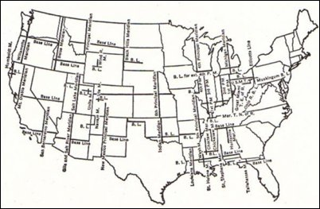
You'll notice that the Meridians converge as they go north. That, of course, is because of the curvature of the earth. Most of the effort involved in this sort of land description relates to different ways to describe squared boundaries on a spherical globe. It's like trying to put a postage stamp on an orange; you've got to figure out ways to iron out the wrinkles.
Fig. 2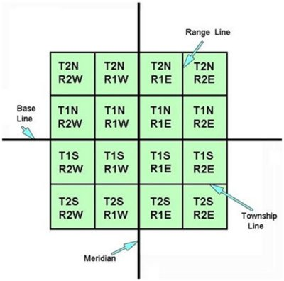

Starting from a baseline and a meridian line, Township Lines and Range Lines lay out a grid of 6-mile square blocks. For example, the first line 6 miles north of the Base Line is named Township 1 North of the Base Line, and the first line 6 miles east of the Meridian is Range 1 East of the Principle Meridian. The block that those two lines form is called Township 1 South, Range 1 East, or T1S,R1E.
Each Township and Range is further divided into 1-mile squares called Sections. The most important thing to remember about this stage of the process is that the 36 sections are numbered and arranged BOTH left to right AND right to left, as in Figure 3 below.
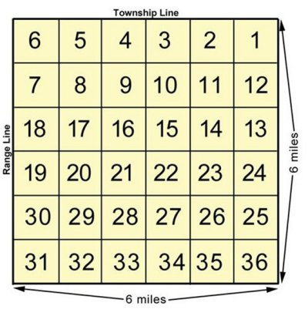
Fig. 3.

Then once you get inside a Section, that's when things really get interesting… or complicated, depending on your point of view. Each section can be divided into quarters and halves, so that a quarter-section is 160 acres and a quarter of a quarter is 40 acres. In Figure 4 below the top ten-acre square in the northwest corner is described as "The Northwest Quarter of the Northwest Quarter of the Northwest Quarter of Section 12 Township 28N, Range 8 West" which is abbreviated NE1/4,NW1/4,NW1/4, S12 T28N R8W, or simply NE NW NW 12-28-8.
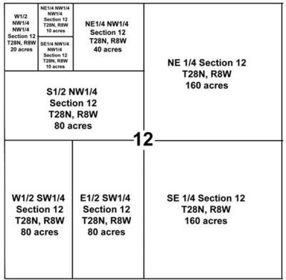
Fig. 4

Assume that you want to find “All of the Northwest Quarter of the Southwest Quarter of the Southeast Quarter of Section 16, Township 29 North, Range 2 East. The easiest way to decipher any legal description is to start at the end and work backward.
Here’s how we do that: In this case, we want to locate the property on a topo map, so we find the correct map by township and range, and we locate Section 16 in Township 29 North, Range 2 East. A typical section is one mile square and contains 640 acres.
Next, we find the center of the section by drawing diagonals from each corner. Then we locate the Southeast Quarter of Section.16, as shown in Figure 30. A typical Quarter Section is a half-mile square and contains 160 acres.
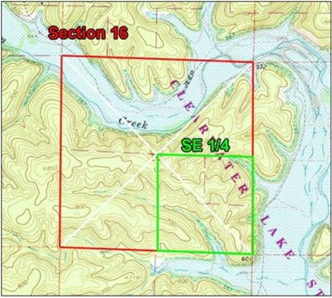
Using the same technique of drawing diagonals, we locate the Southwest Quarter of the Southeast Quarter of Section 16. A typical Quarter-Quarter Section is a quarter-mile square and contains 40 acres.
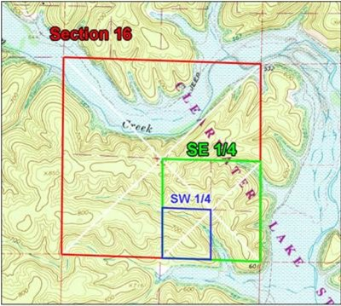
And finally, we locate the Northwest Quarter of the Southwest Quarter of the Southeast Quarter of Section 16, Township 29 North, Range 2 East. A typical Quarter-Quarter-Quarter Section is 660 feet square and contains 10 acres.
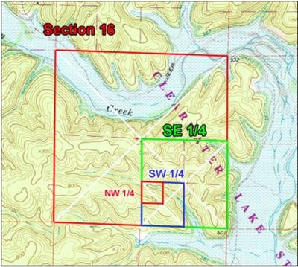
You'll notice that I keep using the term "typical section". Not all sections are the same size, especially those on the north and west side of a township block. These are frequently contracted or expanded to make up for the curvature of the earth. The yellow sections below are examples. The sections along the northernmost tier of T 29 N are all about a mile wide by around 2-1/2 miles tall. Here's how this is handled.
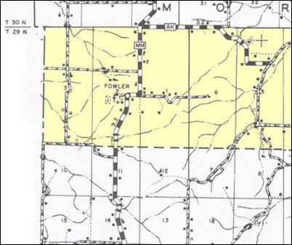
The southernmost Quarter Sections, the SW and the SE are of about normal size, around a half-mile square. However the remaining two miles is divided up into two so-called “quarters”, the NW and the NE, and each of those is divided into eight "lots" of about 80 acres each. To complicate things, while this is the most common configuration for outsize sections, you may encounter others.
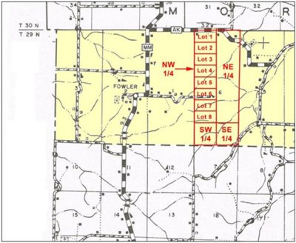

Stephen M. Parham, Bloom Sugarman LLP, 977 Ponce de DeLeon Ave, NE, Atlanta, GA 30306.

